LED Par light
User Manual

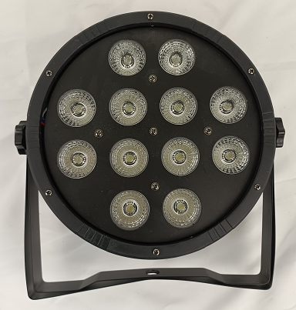

12pcs RGBW 5in1 LED Par light

USER MANUAL

Product Specification
- 5/9 DMX512 channels
- Sound-Active/Auto-Play/DMX 512/Master-Slave
- LED display
- 3-pins XLR input/output
- Power supply: AC100V-240V 50/60Hz
- LED: 12pcs RGBW+UV LED
- Protection Rate: IP20

LED display

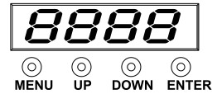

Operation instruction: Press button MENU will cycle display 10 different function effects, the front two value of LED digit means the current function( see function map). The end two value means functions’ address and speed. Press DOWN or UP can adjust different value, press ENTER to enter.

LED digit display menu instruction
NO | Display | Value | Function
1 | d001 | 001- 512 | DMX512 5DMX channel address setting
2 | A001 | 001- 512 | DMX512 9DMX channel address setting
3 | r255 | 000 - 255 | red dimmer from 0-100%
4 | G255 | 000 - 255 | green dimmer from 0-100%
5 | b255 | 000 - 255 | blue dimmer from 0-100%
6 | u255 | 000 - 255 | white dimmer from 0-100%
7 | Y255 | 000 - 255 | UV dimmer from 0-100%
8 | FH99 | 01 - 99 | strobe slow to fast
9 | CL01 | 01-08 | 8 color effect
10 | CC99 | 01 - 99 | jump color change slow to fast
11 | DE99 | 01 - 99 | color fading slow to fast
12 | CP99 | 01 - 99 | pulse change slow to fast
13 | SU01 | 01-09 | sound activated

DMX 512 Channel
Channel |  | Value | Function
5CH | 9CH | Value | Function
 | CH1 | 0-255 | Master dimmer
CH1 | CH2 | 0-255 | Red dimmer
CH2 | CH3 | 0-255 | Green dimmer
CH3 | CH4 | 0-255 | Blue dimmer
CH4 | CH5 | 0-255 | White dimmer
CH5 | CH6 | 0-255 | UV dimmer
 | CH7 | 0-255 | Strobe slow to fast
 | CH8 | 0-50 | DMX dimmer
 | CH8 | 51-100 | 8 color effect
 | CH8 | 101-150 | jump color change
 | CH8 | 151-200 | color fading
 | CH8 | 201-250 | pulse change
 | CH8 | 251-255 | sound activated
 | CH9 | 0-255 | speed slow to fast

Safety instruction
The electric connection must carry out by qualified person.
Make sure that the available voltage is not higher than stated at the end of this manual.
Make sure the power cord is never crimped or damaged by sharp edges. If this would be the case, replacement of the cable must be done by an authorized dealer.
If the external flexible cable or cord of this luminaire is damaged, it shall be exclusively replaced by the manufacturer or his service agent or a similar qualified person in order to avoid a hazard.
Please cut off the power if don't use the fixture or want to clean, maintenance.

